**Laborator Afaceri Electronice 4**

**Obiective:**

Index.php

produs.php

cos.php

casa.php

prelucrare.php

* Lucrul cu sesiuni PHP
* Check-out cos cumparaturi

**Pasii**

1. **Actualizare baza de date**
   1. **Creare tabela tranzactii**

**CREATE TABLE tranzactii(id_tranzactie INT unsigned NOT NULL auto_increment, data_tranzactie TIMESTAMP(10) NOT NULL, nume_cumparator TEXT NOT NULL, adresa_cumparator TEXT NOT NULL, UNIQUE KEY id_tranzactie (id_tranzactie));**

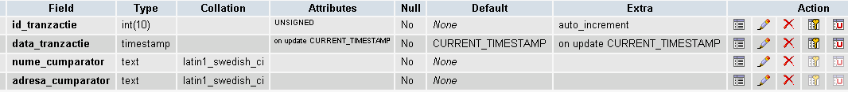

* 1. **Creare tabela vanzari**

**CREATE TABLE vanzari(id_tranzactie int unsigned NOT NULL, id_produs int unsigned NOT NULL, nr_buc tinyint NOT NULL)**

**ALTER TABLE vanzari ADD PRIMARY KEY(id_tranzactie, id_produs)**

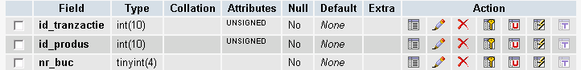

1. **Dezvoltare scripturi php pentru vizualizarea comenzii finale**
   1. **Foloseste ultima varianta de site sau descarca de la adresa:** *http://ebusiness.ase.ro/ae/ecommerce3.0.zip*
   2. **casa.php – Confirmare comanda finala (itemuri & valoare)**

|  |  |
| --- | --- |
| **Controller casa – casa.php**  **<?php *session_start*();  include("includes/conectare.php");  include("services/categoriiService.php");  include("services/totalService.php");  include ("includes/top.php");  include ("includes/meniu.php");  include("views/casaView.php");  include("includes/right.php");  include ("includes/footer.php"); ?>** | **Functie total – totalService.php**  **<?php  $achizitie = array();  $total = 0;  for($i=0; $i<*count*($_SESSION['id_produs']);$i++) {  $achizitie[] = $_SESSION['nr_buc'][$i]*$_SESSION['pret'][$i];  $total=$total+$achizitie[$i]; } ?>** |

**View casa – casaView.php – similar in buna parte cu cosView.php**

**<section id="content">  
 <h1>Comanda dvs este:</h1>  
 <table border="1"> <tr>  
 <td> Numar bucati</td>  
 <td> Carte </td>  
 <td> Pret </td>  
 <td> Total </td>  
 </tr>  
 <?php for($i=0; $i<*count*($_SESSION['id_produs']); $i++): ?>  
 <?php if($_SESSION['nr_buc'][$i]>0): ?>  
 <tr><td> <?=$_SESSION['nr_buc'][$i]?> </td>**

**<td><b> <?=$_SESSION['den_prod'][$i]?></b> de <?=$_SESSION['den_producator'][$i]?></td><td><?=$_SESSION['pret'][$i]?> lei </td><td><?=$achizitie[$i]?> lei  
 </td></tr>  
 <?php endif; ?>  
 <?php endfor; ?>  
 <tr><td colspan="3"><b>Total cumparaturi</b></td><td><b><?=$total?></b> lei </td></tr>  
 </table>  
 <form action="prelucrare.php" method="post">  
 <table> <tr>  
 <td> Numele:</td>  
 <td> <input type="text" name="nume" /> </td>  
 </tr><tr>  
 <td> Adresa </td>  
 <td> <textarea name="adresa" rows="7"></textarea></td>  
 </tr><tr>  
 <td></td>  
 <td> <input type="submit" value="Trimite" /></td>  
 </tr></table>  
 </form>  
</section>**

1. **Dezvoltare scripturi php pentru inregistrarea comenzii finale**

|  |  |
| --- | --- |
| **Controller pagina inregistrare tranzactie:**  **<?php  $err = array();  if(empty($_POST['nume'])) $err[] = "Nume necompletat";  if(empty($_POST['adresa'])) $err[] = "Adresa necompletata";  *session_start*();  $numar_produse = *array_sum*($_SESSION['nr_buc']);  if($numar_produse == 0) $err[] = "Trebuie cumparat macar un produs";  if (empty($err)) {  include("services/inregistrareService.php");  *session_unset*();  *session_destroy*();  }  include("includes/conectare.php");  include("services/categoriiService.php");  include ("includes/top.php");  include ("includes/meniu.php");  include("views/inregistrareView.php");  include("includes/right.php");  include ("includes/footer.php"); ?>** | **Model pagina inregistrare tranzactie:**  **<?php  $tranzactie = "insert into tranzactii(nume_cumparator, adresa_cumparator) values('".$_POST['nume']."','".$_POST['adresa']."')";  $res = *mysql_query*($tranzactie);  $id_tranzactie = *mysql_insert_id*();  for($i=0;$i<*count*($_SESSION['id_produs']);$i++) {  if($_SESSION['nr_buc'][$i]>0) {  $sql_vanzare="insert into vanzari values('".$id_tranzactie."','".$_SESSION['id_produs'][$i]."','".$_SESSION['nr_buc'][$i]."')";  *mysql_query*($sql_vanzare); } } ?>**  **View pagina inregistrare tranzactie: inregistrareView.php**  **<?php if (empty($err)): ?>  <td> <h1>Multumim pentru cumparaturi</h1> </td>  <?php  else:  foreach ($err as $e) {  echo "<div>".$e."</div>"."<a href=\"cos.php?actiune=vizualizeaza\">Back</a>";  } endif; ?>** |